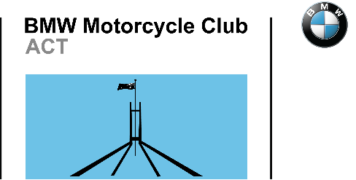
BMW Motorcycle Club ACT Incorporated
2021 Annual General Meeting
Proxy Voting Form

You can complete this form online and email it back to the Public Officer or print, complete and return this form as a PDF, picture or by @mail. You MUST be a financial member of the BMWMCCACT Inc. to vote at the AGM. Your email address will be used as the record of signature.
I, Click here to enter text.,
(Type/write your name)
Of Click here to enter text.,
(Type/write your residential address)
being a current financial member of the BMW Motorcycle Club ACT Incorporated (BMWMCCACT, the Club) appoint Choose an item.
(Type/write name of proxy)
as my proxy for the Click here to enter text. Annual General Meeting and voting on the election of office bearers and resolutions.
Or where valid nominations for the following positions have been notified to members:
Position | Write the name of the valid nominee
President: | Click here to enter text.
Vice President: | Click here to enter text.
Secretary: | Click here to enter text.
Treasurer: | Click here to enter text.
Membership Secretary | Click here to enter text.
Click here to enter text. | Click here to enter text.
Click here to enter text. | Click here to enter text.
Click here to enter text. | Click here to enter text.
Click here to enter text. | Click here to enter text.

Signed: Click here to enter text. Date: Click here to enter text.
(sign or insert your email address) (insert date)
You can print, complete, scan and return this form to the Club Public Officer by email publicofficer@bmwmccact.or.au or post for the attention of thePublic Officer BMWMCCACT Inc. PO Box 4042 Weston Creek 2611 ACT. The Club Public Officer must receive your Proxy Voting forms by 1700 the day before the AGM.

